MINISTRY OF HEALTHCARE OF THE RUSSIAN FEDERATION
GENERAL PHARMACOPEIAL MONOGRAPH
Dissolution of solid pharmaceutical dose forms | GPM.1.4.2.0014.15  Instead of GPM 42-0003-04
Dissolution test is intended for assaying active ingredient which shall release into dissolution medium from a solid pharmaceutical dose form within a set period of time and under conditions specified in pharmacopeial monograph or normative documentation.
Pharmacopeial monograph or normative documentation specifies the following for each specific solid pharmaceutical form:
- Drug type
- Dissolution medium – its composition and volume;
- Rotation rate of stirrer for apparatuses I and II or dissolution medium flow rate for apparatus III
- Sampling time;
- Analytical method for assaying active ingredient/s released into dissolution medium;
- Volume of active ingredient to be released into dissolution medium within a specified period of time expressed in % of label claim.
Dissolution test is conducted along with quality control of pharmaceutical form to confirm stability of its properties and proper conditions of manufacturing process.
Depending on release velocity rate of active ingredients all solid pharmaceutical dose forms are classified into the following groups:
1st group: tablets; film-coated tablets; granules (dissolution time of which exceeds 5 min); film-coated granules; capsules;
2nd group: enteric-coated tablets; enteric-coated capsules, granules and other enteric-coated solid pharmaceutical dose forms;
3rd group: tablets, capsules and granules with extended release
Dissolution test for multicomponent solid pharmaceutical dose forms can be conducted for the least soluble active ingredient.
Equipment
Apparatus choice depends on physical and chemical properties of solid pharmaceutical dose form.
All apparatus parts that can come in contact with drug substance and dissolution medium shall be chemically inert and shall not influence analysis results. Metal apparatus parts shall be manufactured from stainless steel or covered with a proper material to guarantee absence of interaction with dissolution medium or active ingredient.
There shall be no part or assembly condition that can cause vibration, movement or shift during testing, except for steady rotation of stirring device.
Dissolution apparatuses shall correspond to geometrical and technical parameters provided in the present pharmacopeial monograph.
Apparatus I “Rotating Basket”
The assembly I (pic. 1) consist of the following:
- dissolution vessel (В) with semi-spherical bottom from borosilicate glass or other proper transparent inert material. Rated capacity of dissolution vessel is 1000 mL; height - 185 + 25 mm; inner diameter - 102 ± 4 mm;
- A motor with speed adjuster that keeps basket rotation speed within the limit of ±4 % of basket rotation speed specified in pharmacopeial monograph or normative documentation;
- Stirring unit comprising vertical shaft (А), with cylindrical basket mounted onto the bottom (Б). Shaft axis of rotation shall not deviate from vessel vertical axis in more than 2 mm. Shaft rotation shall be steady, without significant vibration.
Basket includes two parts: the upper part with an opening 2.0 + 0.5 mm in diameter that shall be welded onto the shaft and equipped with 3 elastic clamps or other proper devices for removing the bottom part of the basket to inject a test drug. A detachable part of the basket is made from metal wire-netting with wire of 0.21-0.31 mm in diameter forming openings 0.36-0.44 mm in size. Wire-netting is cylindrical in form and bounded with metal frame from upwards and downwards.
If aggressive acid solutions are used, a basket with gold coating 2.5 mcm thick can be applied.
Distance between dissolution vessel bottom and basket shall be 23 - 27 mm.
To avoid evaporation of dissolution medium dissolution vessels shall be closed with caps with central hole and holes for thermometer and sampling.
To maintain dissolution medium temperature (37 ± 0.5) °С apparatus shall be equipped with water bath with constant volume of thermostating liquid.
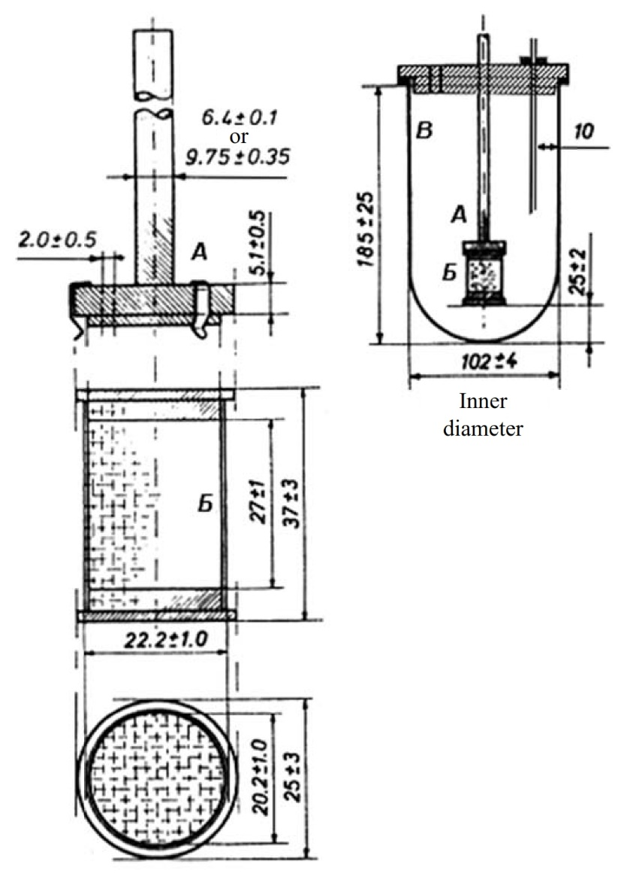
Pic. 1 – Apparatus I “Rotating basket”
Measurements are provided in mm
Apparatus II «Paddle apparatus»
Apparatus II comprises the same parts as Apparatus I.
The difference of Apparatus II is that it uses a paddle as a stirring element (pic. 2) instead of rotating basket.
Metal stirrer and metal bar represent a sole unit.
The lower end of stirrer blade is positioned 23 - 27 mm away from dissolution vessel bottom.
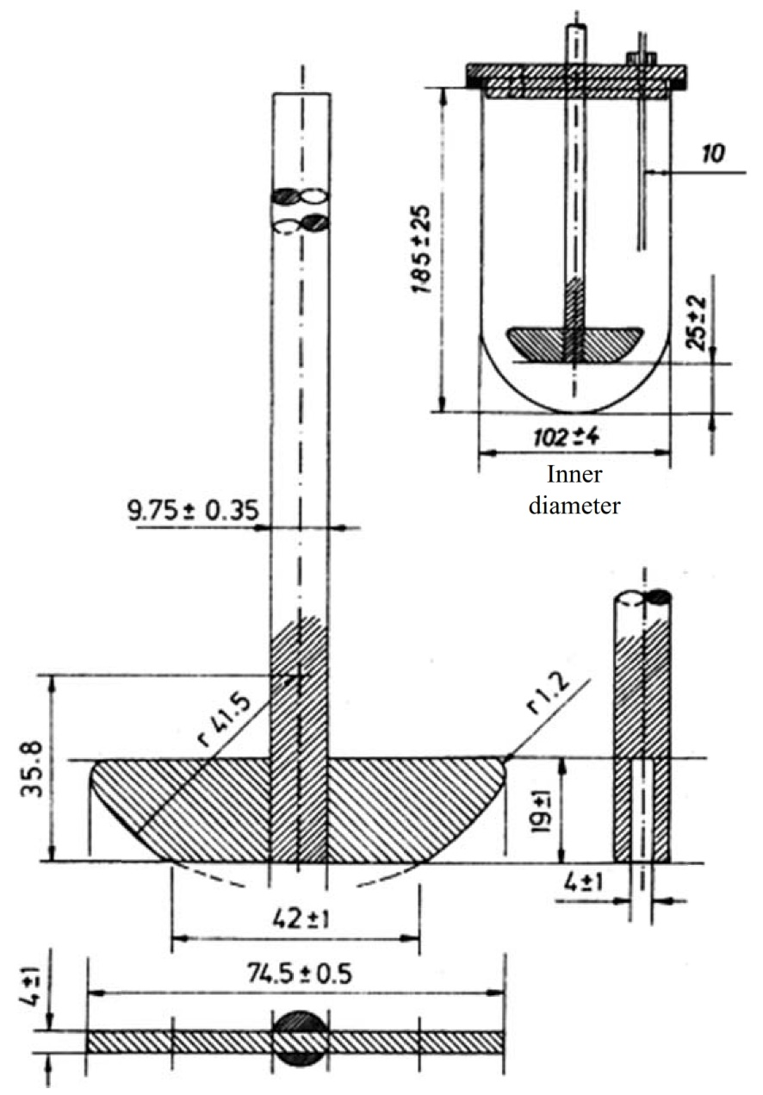
Pic. 2 - Apparatus II “Paddle apparatus” Measurements are provided in mm
Apparatus III “Continuous-flow cell”
Apparatus III (pic. 3) comprises the following:
- a vessel for dissolution medium;
- Sinusoidal pump with speed 120 ± 10 impulses/ min delivering dissolution medium through a continuous-flow cell; flow rate of dissolution medium shall not exceed ±5 %;
- A continuous-flow cell (pic. 3-5) from transparent inert material mounted vertically above filter system that prevents undissolved monograph s from moving to the upper part of the cell. Standard cell diameters are 12.0 and 22.6 mm. Cell size, characteristics of filter system, flow rate of dissolution medium shall be specified in pharmacopeial monograph or normative documentation;
- A water bath with dissolution medium temperature (37 ± 0.5) °С.
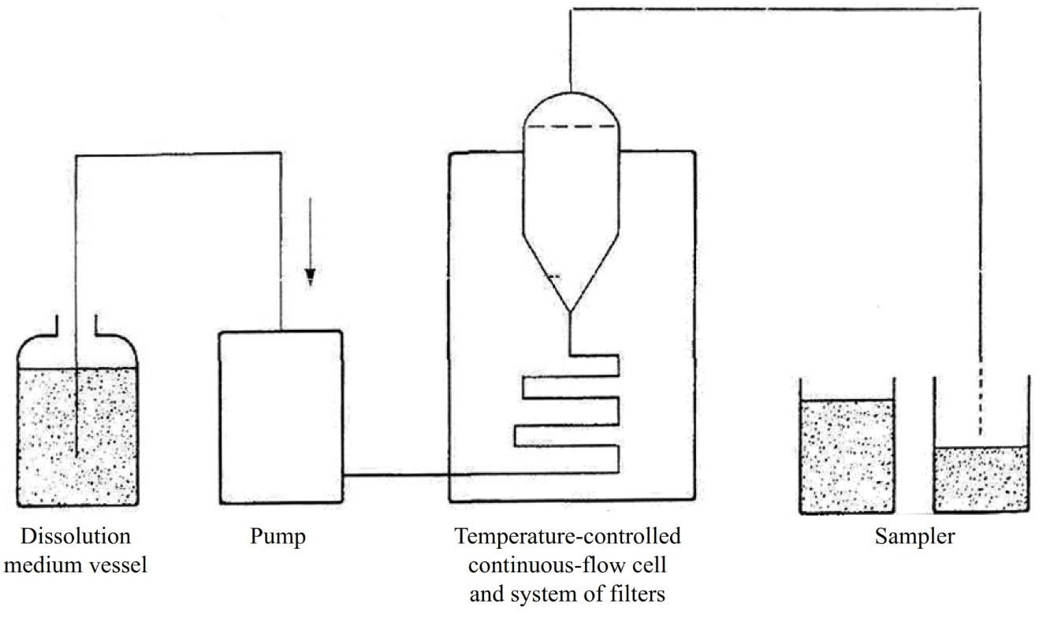
Pic. 3 Scheme of Apparatus III “Continuous-flow cell”
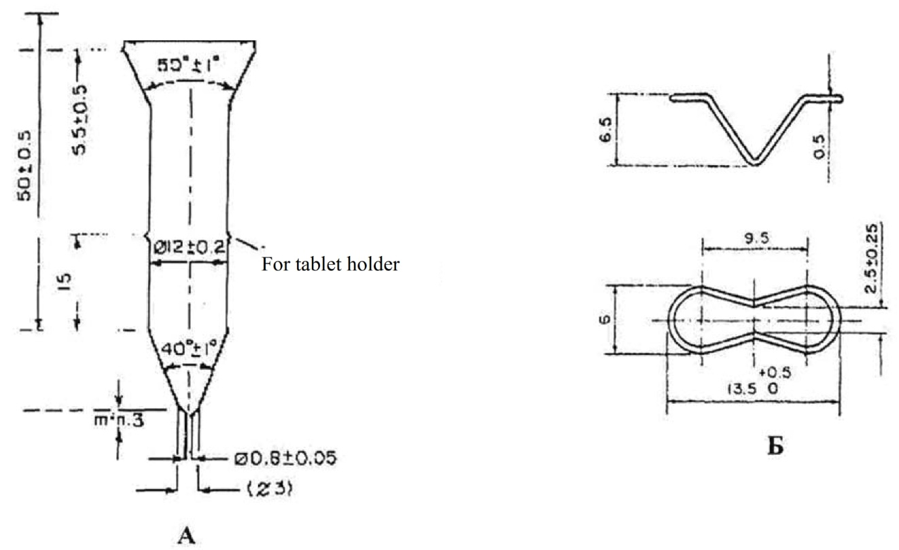
Pic. 4 Continuous-flow cell 12.0 mm (A) and tablet holder for continuous-flow cell 12.0 mm (Б)
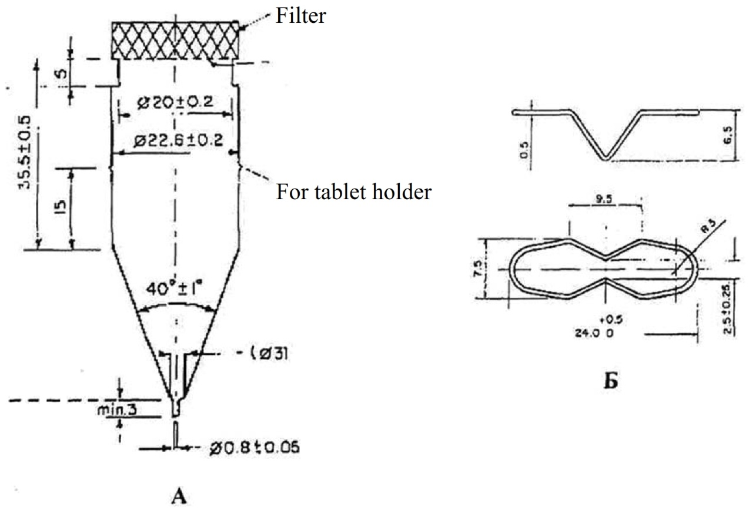
Pic. 5 – Continuous-flow cell 22.6 mm (A) and tablet holder for continuous-flow cell 22.6 mm (Б)
Note. Other apparatuses described in foreign monographs can be used for dissolution test; the main characteristics of such equipment shall be stated in pharmacopeial monograph or normative documentation.
Dissolution medium
The following substances can be used as dissolution medium: purified water, 0.1 M solution of hydrochloric acid, buffer solutions with рН 6.8-7.8 (acceptable deviation of pH values is ±0,05), and other solutions specified in pharmacopeial monograph or normative documentation. If gelatin-containing solid or soft gel capsules, or film-coated tablets do not meet the requirements of dissolution test when water or media with pH less than 6.8 are used as dissolution medium, the test is repeated in the same medium but with addition of purified pepsin (with activity no more than 750000 units per 1 L), or if water and media with pH more than 6.8 are used as dissolution medium, the test is repeated in the same medium but with addition of pancreatine (with activity no more than 1750 units of protease activity per 1 L). Retest conditions are specified in pharmacopeial monograph or normative documentation.
Medium рН value shall not exceed 7,8, unless otherwise justified during test development.
Use of water solutions with addition of enzymes, surface acting agents (for example, sodium dodecyl sulfate, twin -80 and others) or organic solvents shall be justified during test development. It is not recommended to use organic solvents.
For poorly soluble substances dissolution medium with surface acting agents is recommended.
Dissolution medium volume for rotating basket and paddle apparatus is 900 mL, but no less than 500 mL, unless otherwise stated in pharmacopeial monograph or normative documentation.
Dissolution medium temperature shall be controlled throughout the whole test and comprise (37 + 0.5) °С.
Before use dissolution medium shall be deaerated. Heat dissolution medium to app. 41 °С, carefully mix, and filter immediately under vacuum through a 0.45-mcm filer while mixing vigorously. After filtration expose to vacuum during 5 min.
Any other validated degassing method can be applied for deaeration.
Necessity of dissolution medium deaeration is confirmed experimentally. The fact that deaeration has no impact on release of active ingredient into dissolution medium shall be stated in pharmacopeial monograph or normative documentation.
Paddle apparatus rotation speed
Unless otherwise stated in pharmacopeial monograph or normative documentation, paddle apparatus rotation speed shall be 100 rpm (for rotating basket) or 50 rpm (for paddle apparatus).
Acceptable deviation in rotation speed of paddle apparatus shall not exceed ±4 % of rotation speed stated in pharmacopeial monograph or normative documentation.
Sampling
Samples are taken from the area of dissolution vessel that is half distance between dissolution medium surface and the upper part of detachable element of basket or paddle and no less than 1 cm away from vessel walls.
Sampling time shall be specified in pharmacopeial monograph or normative documentation and shall be followed with accuracy of ±2 %.
For drugs of the 1st group, unless otherwise stated in pharmacopeial monograph or normative documentation, samples are taken in 45 min after beginning of the test.
For drugs of the 2nd group 2 controlled periods of time shall be stated – one for acid stage, the other of alkali stage.
For drugs of the 3rd group minimum 3 periods of time shall be specified.
After each act of sampling volume of dissolution medium shall be replenished with the solvent volume equal to that of sampled aliquot. If preliminary tests show optionality of dissolution medium replenishment, decrease in dissolution medium shall be considered in calculations of drug content released into dissolution medium.
Filter immediately solution aliquot sampled from dissolution medium through inert filter that shall not absorb active ingredient from solution and shall not contain substances that can be extracted by dissolution medium. Filter pore size shall be no more than 0.45 mcm unless otherwise stated in pharmacopeial monograph or normative documentation.
Aliquot centrifugation is not allowed.
Analytical method for active ingredient assay in solution shall be described in pharmacopeial monograph or normative documentation and validated in compliance with predetermined requirements.
If capsule shell influences analysis result, correction factor shall be determined in the following way: conduct dissolution test on capsules used for manufacture of the pharmaceutical form, but without active ingredient. Correction factor is taken into consideration in calculations of active ingredient content released into dissolution medium. Correction factor shall not exceed 25% of label claim of active ingredient.
If analytical method for determination of active ingredient in solution allows no evaluation of dissolution from one unit of solid pharmaceutical dose form, it is possible to test several unit of this pharmaceutical form (Pooled Sample) per each dissolution vessel.
Test method
Put a definite volume of dissolution medium into apparatus vessel. Bring up dissolution medium temperature to (37 ± 0.5) °С.
If rotating basket is used, and there are no instructions in pharmacopeial monograph or normative documentation, place one unit of pharmaceutical form into each of 6 dry baskets of the apparatus. Immerse baskets into dissolution medium and run the motor that rotates mixing element.
If paddle apparatus is used, and there are no instructions in pharmacopeial monograph or normative documentation, place one unit of pharmaceutical form into each of 6 vessels with dissolution medium prior to rotation. To avoid tablets and capsules from rising to the surface apparatus set shall include a proper sinker in the form of a wire made of inert material or a glass spiral for holding tablets or capsules on vessel bottom. Application of other sinkers is acceptable. Caution shall be taken to avoid collapse of bubbles onto surface of tablets or capsules.
If a continuous-flow cell is used, place 1 ball 5.0 ± 0.5 mm in diameter and then glass balls of proper size, usually 1.0 ± 0.1 mm (included into apparatus set), onto the bottom of conic part of continuous-flow cell to prevent liquid from passing into a pipe. Place pharmaceutical form unit, unless otherwise stated in pharmacopeial monograph or normative documentation, into the cell or immediately in glass balls layer. Close apparatus by filter system.
For solid pharmaceutical dose forms of the 2nd group one of the two methods for dissolution testing can be applied. Reference to used method is included into pharmacopeial monograph or normative documentation.
Method 1
Conduct test by two stages.
1st stage (acid). Unless otherwise stated in pharmacopeial monograph or normative documentation, place 750 mL of 0.1 M solution of hydrochloric acid into each of the 6 dissolution vessels. Bring up medium temperature to (37 + 0.5) °С. Unless otherwise stated in pharmacopeial monograph or normative documentation, place 1 tablet or 1 capsule into each of the 6 dissolution vessels, run the motor that rotates mixing element. Unless otherwise stated in pharmacopeial monograph or normative documentation, in 2 hours sample aliquot and continue process of dissolution in alkali medium as described further.
Analyze sampled aliquot according to method described in pharmacopeial monograph or normative documentation. Test results of the 1st stage are considered satisfactory if amount of active ingredient released into dissolution medium corresponds to criteria specified in “Results interpretation” section (tabl. 1).
2nd stage (alkali). Add 250 mL of 0.2 M solution of sodium phosphate (Na₃PO₄ • 12H₂O) with temperature of (37 + 0.5) °С (mixing element of apparatus continues working). Bring рН of dissolution medium to 6.80 + 0.05 with 2 M solution of hydrochloric acid or 2 M solution of sodium hydroxide.
Continue dissolution process during 45 minutes, unless otherwise stated in pharmacopeial monograph or normative documentation. After sampling determine content of active ingredient in solution according to the method described in pharmacopeial monograph or normative documentation. Test results of the 2nd stage are considered satisfactory if amount of active ingredient released into dissolution medium corresponds to criteria specified in “Results interpretation” section (tabl. 1).
Note. Addition of 0.2 M solution of sodium phosphate and brining pH of dissolution medium to set value shall be conducted within maximum 5 minutes.
Method 2
Conduct test by two stages.
1st stage (acid). Unless otherwise stated in pharmacopeial monograph or normative documentation, place 1000 mL of 0.1 M solution of hydrochloric acid into each of the 6 dissolution vessels. Bring up medium temperature to (37 + 0.5) °С. Unless otherwise stated in pharmacopeial monograph or normative documentation, place 1 tablet or 1 capsule into each of the 6 dissolution vessels, run the motor that rotates mixing element. Unless otherwise stated in pharmacopeial monograph or normative documentation, in 2 hours sample aliquot and continue process of dissolution in alkali medium as described further.
Analyze sampled aliquot according to method described in pharmacopeial monograph or normative documentation. Test results of the 1st stage are considered satisfactory if amount of active ingredient released into dissolution medium corresponds to criteria specified in “Results interpretation” section (tabl. 1).
2nd stage (alkali). Remove 0.1 M solution of hydrochloric acid from each dissolution vessel and add 1000 mL of phosphate buffer solution with 6.8 (2) and temperature (37 ± 0.5) °С. it is acceptable to transfer test units of solid pharmaceutical dose form from dissolution vessels containing 0.1 M solution of hydrochloric acid into dissolution vessels containing 1000 mL of phosphate buffer solution with 6.8 (2) and temperature (37 ± 0.5) °С.
Continue dissolution process during 45 minutes, unless otherwise stated in pharmacopeial monograph or normative documentation. After sampling determine content of active ingredient in solution according to the method described in pharmacopeial monograph or normative documentation. Test results of the 2nd stage are considered satisfactory if amount of active ingredient released into dissolution medium corresponds to criteria specified in “Results interpretation” section (table 1).
Note. Preparation of phosphate buffer solution with рН 6,8 (2). Mix 0.1 M solution of hydrochloric acid and 0.2 M solution of sodium phosphate (Na₃PO₄ • 12H₂O) in 3:1 ratio and if necessary bring pH of the solution to 6.80 + 0.05 with 2 M solution of hydrochloric acid or 2 М solution of sodium hydroxide.
Apparatus, test method and analytical method for determination of content of active ingredient in solution for solid pharmaceutical dose forms of 3rd group shall be described in pharmacopeial monograph or normative documentation.
Results interpretation
1st group. Tablets, fil-coated tablets, capsules.
Unless otherwise stated in pharmacopeial monograph or normative documentation, amount of active ingredient released into dissolution medium having temperature of (37 ± 0.5) °С, within 45 minutes under basket rotation speed 100 rpm or rotation speed of paddle apparatus 50 rpm shall be no less than 75 % (Q) of label claim.
Conduct test on 6 units or 6 pooled samples of solid pharmaceutical dose form. Test results are considered satisfactory if amount of active ingredient released into dissolution medium complies with criteria specified in table 1, stage S₁.
If one result does not correspond to the norm specified in pharmacopeial monograph or normative documentation, then repeat dissolution test on 6 units or 6 pooled samples of solid pharmaceutical dose form. Results are interpreted in accordance with table 1, stage S₂.
If results of retest do not comply with predetermined criteria, repeat test on 12 additional units or 12 pooled samples of solid pharmaceutical dose form. Results are interpreted in accordance with table 1, stage S₃.
Unless otherwise stated in pharmacopeial monograph or normative documentation, a lot is rejected if test results of none of the stages meet the set criteria.
Table 1 –Interpretation of dissolution test results for solid pharmaceutical dose forms of the 1st group
Stage | Number of test samples | One unit of pharmaceutical form | Pooled sample
S₁ | 6 | For each test unit: no less than Q + 5 % of label claim of active ingredient shall release into dissolution medium | Average amount of active ingredient released into dissolution medium for each drug unit from 6 pooled samples shall be no less Q + 10 % of label claim of active ingredient
S₂ | 6 | Average amount of active ingredient released into dissolution medium from из 12 test units of pharmaceutical form (S₁ + S₂) shall be no less than Q and there shall be no unit with the amount of active ingredient released into dissolution medium less than Q – 15 % of label claim of active ingredient. | Average amount of active ingredient released into dissolution medium for each drug unit from 12 pooled samples (S₁ + S₂) shall be no less Q + 5 % of label claim of active ingredient
S₃ | 12 | Average amount of active ingredient released into dissolution medium from из 24 test units of pharmaceutical form (S₁ + S₂ + S₃) shall be no less than Q, only for 2 units average amount can be less than Q – 15 %, and there shall be no unit with the amount of active ingredient released into dissolution medium less than Q – 25 % of label claim of active ingredient. | Average amount of active ingredient released into dissolution medium for each drug unit from 24 pooled samples (S₁ + S₂ + S₃) shall be no less Q of label claim of active ingredient
2nd group. Enteric-coated tablets; enteric-coated capsules and other enteric-coated solid pharmaceutical solid forms.
Conduct test on 6 units or 6 pooled samples of solid pharmaceutical dose form for each stage (acid and alkali).
Test results are considered satisfactory if amount of active ingredient released into dissolution medium complies with criteria specified in table 2, stage S₁.
Unless otherwise stated in pharmacopeial monograph or normative documentation, Q value is considered equal to 75 %.
If one result does not correspond to the norm specified in pharmacopeial monograph or normative documentation, then repeat dissolution test on 6 units or 6 pooled samples of solid pharmaceutical dose form. Results are interpreted in accordance with table 2, stage S₂.
If results of retest do not comply with predetermined criteria, repeat test on 12 additional units or 12 pooled samples of solid pharmaceutical dose form. Results are interpreted in accordance with table 2, stage S₃.
Unless otherwise stated in pharmacopeial monograph or normative documentation, a lot is rejected if test results of none of the stages meet the set criteria.
Table 2 –Interpretation of dissolution test results for solid pharmaceutical dose forms of the 2nd group
Stage | Number of test samples | One unit of pharmaceutical form
1st stage (acid)
S₁ | 6 | For each test unit: no more than 10 % of label claim of active ingredient shall release into dissolution medium.
S₂ | 6 | Average amount of active ingredient released into dissolution medium from из 12 test units of pharmaceutical form (S₁ + S₂) shall be no less than 10% and there shall be no unit with the amount of active ingredient released into dissolution medium more than 25 % of label claim of active ingredient.
S₃ | 12 | Average amount of active ingredient released into dissolution medium from из 24 test units of pharmaceutical form (S₁ + S₂ + S₃) shall be no more than 10%, and there shall be no unit with the amount of active ingredient released into dissolution medium more than 25 % of label claim of active ingredient.
2nd stage (alkali)
S₁ | 6 | For each test unit: no more than Q + 5 % of label claim of active ingredient shall release into dissolution medium.
S₂ | 6 | Average amount of active ingredient released into dissolution medium from из 12 test units of pharmaceutical form (S₁ + S₂) shall be no less than Q and there shall be no unit with the amount of active ingredient released into dissolution medium less than Q – 15 % of label claim of active ingredient.
S₃ | 12 | Average amount of active ingredient released into dissolution medium from из 24 test units of pharmaceutical form (S₁ + S₂ + S₃) shall be no less than Q, only for 2 units average amount can be less than Q – 15 %, and there shall be no unit with the amount of active ingredient released into dissolution medium less than Q – 25 % of label claim of active ingredient.
3rd group. tablets, capsules, and granules with extended release
Conduct test on 6 units or 6 pooled samples of solid pharmaceutical dose form for each stage. Test results are considered satisfactory if amount of active ingredient released into dissolution medium complies with criteria specified in table 3, stage S₁.
If one result does not correspond to the norm specified in pharmacopeial monograph or normative documentation, then repeat dissolution test on 6 units or 6 pooled samples of solid pharmaceutical dose form. Results are interpreted in accordance with table 3, stage S₂.
If results of retest do not comply with predetermined criteria, repeat test on 12 additional units or 12 pooled samples of solid pharmaceutical dose form. Results are interpreted in accordance with table 3, stage S₃.
A lot is rejected if test results of none of the stages meet the set criteria.
Table 3 –Interpretation of dissolution test results for solid pharmaceutical dose forms of the 3rd group
Stage | Number of test samples | One unit of pharmaceutical form
1 | 2 | 3
S₁ | 6 | There shall be no test unit for which the amount of active substance released into dissolution media is outside the limits of the set range and less than the value set for test endpoint
S₂ | 6 | Average amount of active ingredient released into dissolution medium from 12 test units of pharmaceutical form (S₁ + S₂) shall be within the limits of the set range and no less than Q and there shall be no less than the value set for test end point. No individual value shall be maximum in 10 % of label claim beyond the set ranged and maximum in 10% of label claim lower than the set range for test endpoint.
S3 | 12 | Average amount of active ingredient released into dissolution medium for 24 test units of pharmaceutical form (S 1 + S2 + S3) shall fall within set ranges and shall not be less than value set for test endpoint. No more than for 2 units out of 24 the amount of active ingredient released into dissolution medium can be maximum 10% of label claim beyond the set range, and maximum 10 % of label claim below the value set for test end point. None unit shall show the amount of active ingredient released into dissolution medium maximum in 20% of label claim beyond the set range and maximum 20% of label claim below the value set for test end point.

